DLD lab report 1
student number: 16329561

We needed to implement an XOR gate function using only NAND gates.

The result is as following:

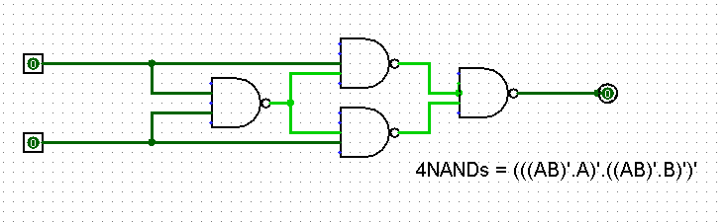
It uses 4 NAND gates in this configuration. The truth table is a follow:

X | Y | F(X,Y)
0 | 0 | 0
0 | 1 | 1
1 | 0 | 1
1 | 1 | 0

We can find this configuration either by luck, or by doing the boolean algebra. We can change the algebraic expression of an XOR with DeMorgan law and this identity : (X+Y’)Y=XY to another expression which only uses NANDs.

Boolean algebra:

First of all the boolean expression of XOR is : XY’+X’Y = XOR(X,Y)

Starting from we get: XY’+X’Y = (XY’+X’Y)
= ((XY’)’.(X’Y)’)’
= ((X’+Y’)Y)’.(X’+Y’)X)’)’
= ((XY)’Y)’.(XY)’)X)’)’

